6000CMD Security Suggested Report Template

Coursework Report
Student Name: Anders Chong Zhan Yan
Student ID: 15337023
Module: 6000CMD Security
Assignment Title: E-commerce Platform Security Analysis and Design

Contents
1. Introduction 3
2. Security Analysis 3
2.1 High- Level System Design 3
2.2 Security Considerations & Threat Modelling 3
2.3 Authentication and Authorization Strategies 3
2.4 Data Protection and Secure Design Decisions 4
2.5 Security Audit & Analysis 4
3. Design & Implementation 5
3.1 Security and Component Design & Implementation 5
4. Conclusion 6

1. Introduction
As required by the assignment, this report examines the development of an e-commerce-style web application with a strong emphasis on security for both the system and its users. The application — Amazing Bargain Mart, commissioned by Amazing Bargain Central Ltd. — supports three user roles: customers, sellers, and administrators. Key features include user authentication, product listing and management, customer reviews with optional images, purchase processing, and a logging subsystem used for analytics and auditing.
Because security is the core focus of this coursework, the system incorporates a range of secure development practices, such as password hashing, role-based access control, protection against SQL injection, and the safe handling of uploaded files. This document presents an analysis of the system’s security posture (Part 1) and a detailed discussion of its design and implementation (Part 2), demonstrating how the application meets the functional and security requirements outlined in the brief.

2. Security Analysis

2.1 High- Level System Design
Utilizing the Flask framework, the system is built with lightweight specifications.
- HTML: Provides the interface for logging in, purchases, and product management.
- Python/Flask: Handles routing, processing, and data storage/extraction.
- SQL: Provides persistent storage with tables for users, products, purchases, reviews, and logs.
The architecture is modular for easier management. The browser is the user’s interaction point, with access determined by role. Users browse and purchase products, sellers manage their listings, and administrators manage users and products. Flask routes validate input, perform database operations, render templates, and integrate logging to capture meaningful activity.

2.2 Security Considerations & Threat Modelling
The threat model focuses on common web-application risks. Important data such as user information, product data, administrative tools, and purchase records must be protected. Attackers may attempt to access or exploit these.
Key threats include SQL injection, cross-site scripting (XSS), session hijacking, social engineering, and unsafe file uploads.
Most users may be non-malicious, but the application must resist harmful input or session abuse. Risks are reduced through parameterized queries, route-level role checks, secure password handling, sanitized file uploads, and restricted database operations. The threat model supports ensuring data protection and predictable application behavior even under malicious input.

2.3 Authentication and Authorization Strategies
Authentication and authorization ensure secure access control. Authentication checks user credentials; authorization enforces access levels.
User Authentication
- Email-based login
- Password hashing using generate_password_hash()
- Passwords stored in password_hash
Session Management
- Flask sessions store user data
- Logging out clears the session
- Closing the tab removes the session state
Authorization
Strict role separation:
- User: browse, purchase, review
- Seller: create/edit products, view sales
- Admin: manage users/products, analytics

2.4 Data Protection and Secure Design Decisions

The system includes multiple measures to protect user data and ensure sensitive operations are secure. Session security is prioritised using a randomly generated secret key and non-permanent sessions.

Secure Storage:

Passwords stored as hashes

Timestamps for accountability

User roles stored securely

Input Validation:

Parameterized queries prevent SQL injection

Image uploads use secure_filename()

Integer/float conversion prevents unexpected input issues

secure_filename() removes dangerous characters and stores files in a controlled directory

Value validation used for product fields, ratings, and purchase amounts

Session Security:

Random secret key

Non-permanent sessions to avoid leftover login states

Analytics Enables:

Tracking suspicious behavior

Understanding usage patterns without storing sensitive information

2.5 Security Audit & Analysis
Security testing used Bandit for static analysis and OWASP ZAP for dynamic scanning.
Bandit Analysis:
Three issues were found and resolved.
- Hardcoded Flask Secret Key (Low)
- Replaced with securely generated key.
- Debug Mode Enabled (High)
- Disabled to prevent debugger exposure.
- Hardcoded Password in Admin Setup Script (Low)
- Replaced with a secure value.
Bandit reported no remaining medium/high-risk issues.

ZAP Analysis :
ZAP reported no high-severity issues: four medium, two low, three informational.
Medium Findings:
- Missing CSRF tokens (acceptable for prototype)
- Buffer overflow alerts (false positives)
- No Content Security Policy
- Missing anti-clickjacking header
Low Findings:
- Server version exposure
- Missing X-Content-Type-Options
Informational:
- Authentication detection
- User-agent fuzzing
- Safe XSS notice on search
No issues were found with SQL injection, authentication bypass, or XSS.

Design & Implementation

3.1 Security and Component Design & Implementation
The design and implementation of the system utilizes a modular and security-oriented approach that quarantines core functions from user interface. Protecting from malicious inputs that may target data or key functions. Python and Flask act as the main backend controller, routing all user inputs and request to a predefined function, where request can be checked for invalid inout, and users. HTML templates provide the user with a UI for easier command of said backend functions. Meanwhile, SQL allows the storage of needed persistent information such as user accounts, products, reviews, purchase history, and logged activities.
User Management and Authentication
The authentication component forms the foundation of the system. To register into the system, users must provide a username, email, and password. Where it will be safely stored in the data tables, after using a salted hash generated by Werkzeug’s password-hashing functions. When users log in, the system will validate the credentials by comparing the two passwords. Then, a session is created containing user ID and role. The session data is needed for role and user separation, thus only a small amount of data is needed. The session data is clear immediately after logging out or closing the website. The measure makes sure that sensitive information will not be carelessly left persistent without needing to.
Role-based access control restricts users to its predesignated sectors, limiting actions. Regular users may browse, purchase, and write reviews of their chosen products. Sellers are given tools for creating and editing their own product listing, and view transaction history. Administrators hold the most oversight, having the right to enforce users, their permissions, and products. All privileged routes contain explicit role checks, ensuring that sensitive actions cannot be accessed through direct URL manipulation.
Product and Seller Components
Product management is implemented as a secure, controlled workflow accessible only to sellers and administrators. Using the provided HTML forms, sellers can create or edit their own listings, which Flask validates before inserting or updating into the database. Images are handled differently, as their filenames need to be sanitized with secure_filename() before uploading to prevent malicious attacks using directory traversal names. To ensure that sellers are only able to edit their own products, Flask verifies the owner of the product before providing the user with their options. To prevent SQL injection these features are implemented using parameterized SQL.
Purchasing and Transaction Handling
As of current the purchase mechanism is very simple only a purchase button that mostly works backend as our focus is on security. When the user submits a purchase request, the system retrieves the product information, validates quantity, records the transaction and logs it for auditing. These logs act as receipts that would be important in case of errors or attacks.
Review System
The review component allows users to submit product reviews with photos and some text formatting. Formatting is done using predefined buttons that insert safe HTML tags. Although reviews are stored with some formatting, the system limits input to avoid arbitrary script injections. The same sanitization method is used for image uploads as for product photographs. Reviews are displayed on the product page after being retrieved from the database, which enhances the trustworthiness of the product.
Administrative Components and Logging
Administrators are given access to the admin dashboard, which grants full control of users and products. Some functions include: the ability to ban or unban sellers, edit and review accounts, edit products. Since admin powers can change system integrity, a system of checks prevents administrator accounts form being modified.
A logging system that tracks user movement is implemented to capture user activity, such as product views, searches, dashboard visits, reviews, and purchases. Every entry includes a user ID, action type, optional details, and timestamp. This data supports analytics displayed on the admin dashboard, including frequently viewed products, active users, and common actions.
Information Flow Summary
Across all components, information flow follows a consistent pattern:
- User performs an action through the interface.
- Flask receives the request and validates it.
- A database query retrieves or modifies data as needed.
- Logs are recorded for relevant actions.
- A template is rendered with updated information.
This predictable structure supports maintainability and secure operation.

4. Conclusion
The implemented e-commerce prototype successfully demonstrates secure design principles while meeting the functional requirements of the specification. By applying password hashing, session control, role-based access, sanitized file handling, logging, and parameterized database queries, the system provides a stable foundation resistant to common web vulnerabilities. The modular design ensures that authentication, product management, reviews, transactions, and administrative features operate independently but cohesively. Security testing through Bandit and OWASP ZAP confirmed the effectiveness of these controls, with only minor prototype-level issues identified. Overall, the system achieves its goal of delivering both functionality and security within a compact and robust architecture.

Appendix:

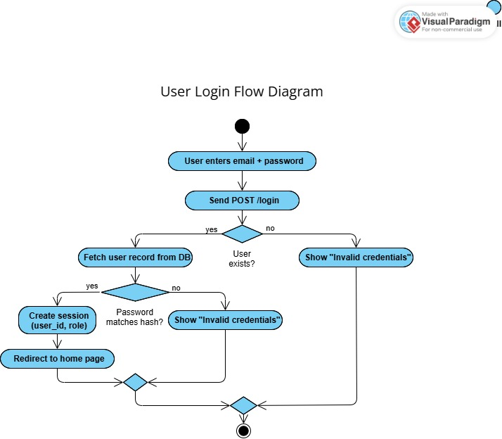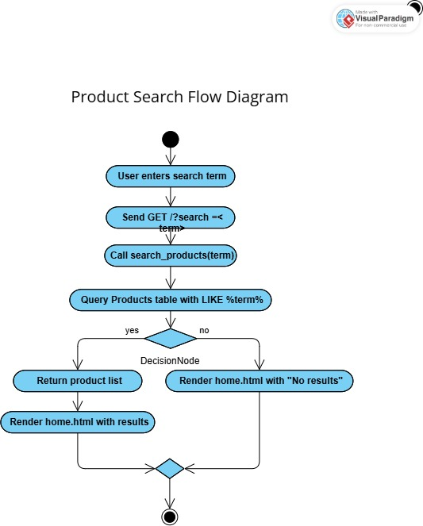

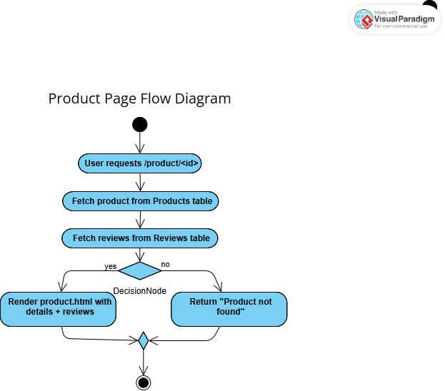

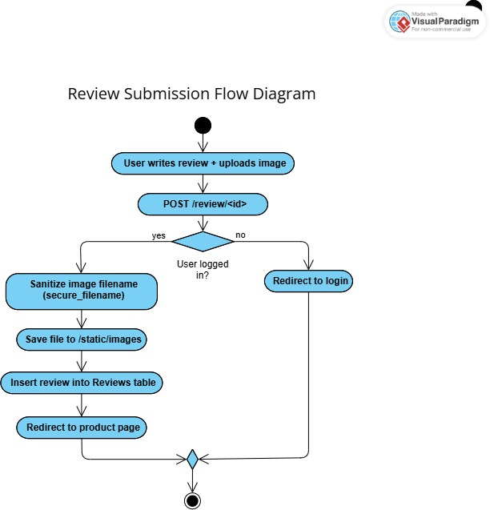
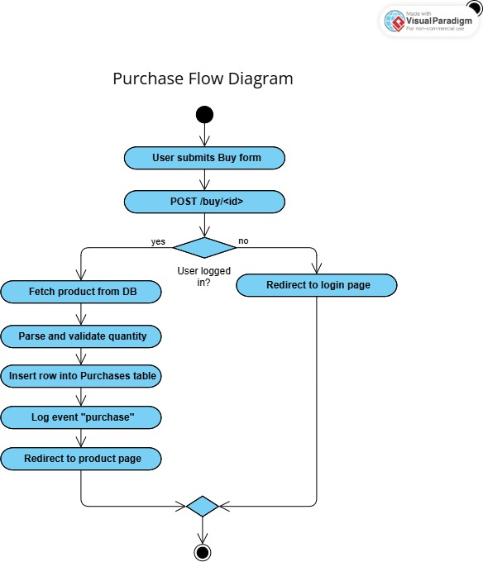
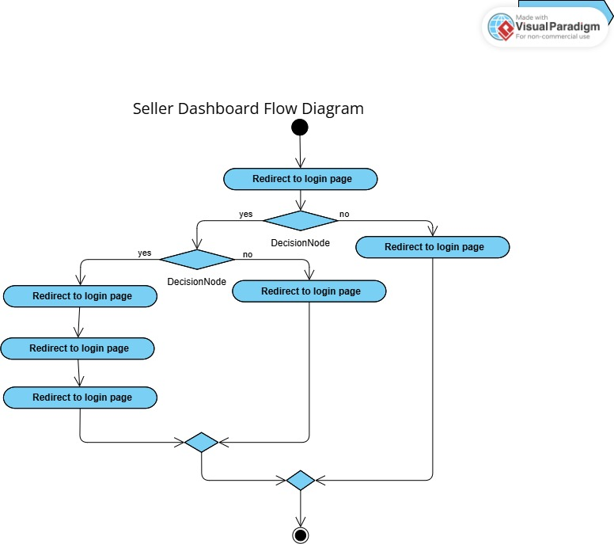

Appendix A:
https://github.coventry.ac.uk/chonga4/Anders_Chong_6000CMD.git

